# File permissions in Linux

## Project description

The task is to reassign file permission via Linux command to better reflect the level of authorization that should be given.

## Check file and directory details

pwd to check current directory



cd /home/searcher2/projects to navigate to projects directory



ls -la to show permissions of all files and hidden files within this directory

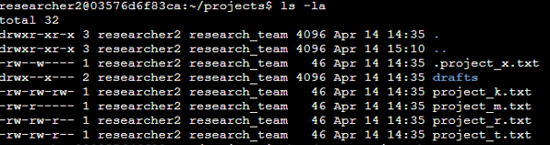

## Describe the permissions string



* **1st character**: This character is either a d or hyphen (-) and indicates the file type. If it’s a d, it’s a directory. If it’s a hyphen (-), it’s a regular file.
* **2nd-4th characters**: These characters indicate the read (r), write (w), and execute (x) permissions for the user. When one of these characters is a hyphen (-) instead, it indicates that this permission is not granted to the user.
* **5th-7th characters:** These characters indicate the read (r), write (w), and execute (x) permissions for the group. When one of these characters is a hyphen (-) instead, it indicates that this permission is not granted for the group.
* **8th-10th characters:** These characters indicate the read (r), write (w), and execute (x) permissions for other. This owner type consists of all other users on the system apart from the user and the group. When one of these characters is a hyphen (-) instead, that indicates that this permission is not granted for others.

## Change file permissions

The assignment instructed to have project_k.txt’s other’s write permission removed to match other project files.

chmod o-w project_k.txt command was executed to remove other’s write permission

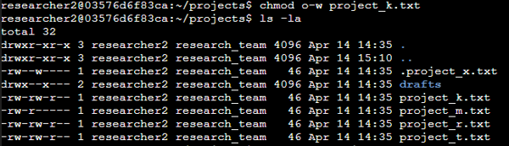

## Change file permissions on a hidden file

The assignment instructed to have the hidden project_x’s write permission removed for every user.

## Change directory permissions

The assignment instructed that only the owner should have access to drafts directory.

chmond g=--- drafts command is executed to remove any permission from groups.

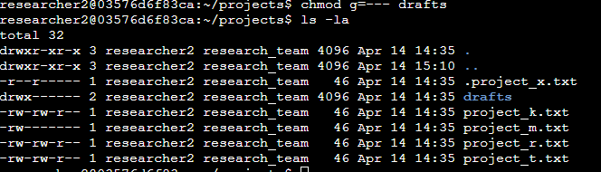

## Summary

pwd and cd are used to navigate to the desired directory.

ls -la is used to check the permissions of the directory, including hidden files.

chmod is used to check permissions for a file, a hidden file, and a directory.